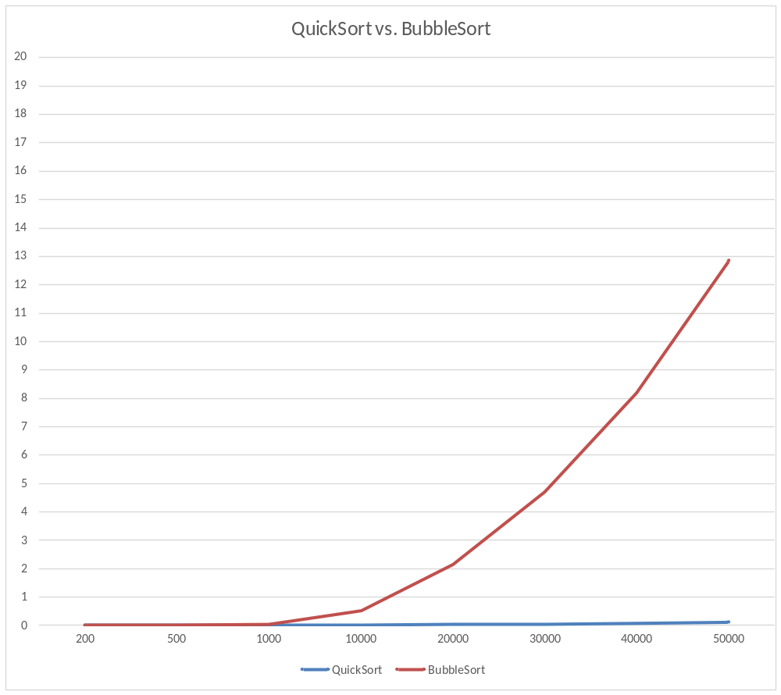
Time was measured from start of sort to end. The time of displaying elements wasn’t added.
Conclusion:
Bubblesort and Quicksort seem to be at equal footing when it comes to sorting time (left column - seconds) while the Array’s elements reach from 200 to 1000. It’s when the elements reach to five figures that they start to split and the discrepancy continues to rise further as the number of elements rise. Bubblesort’s line will continue to rise with more elements added to the array showing that it is indeed O(n^2) as seen by how it resembles a parabola-like line. Quicksort’s line will also continue to rise although at a much slower pace (O(nlogn)). This shows that although bubblesort works well with smaller amounts of elements, it is not a viable sorting algorithm in terms of sorting time for bigger amounts like quicksort is.
Quicksort did start seeing higher sorting time near the millions but it still wasn’t much and I have yet to encounter the worst case of O(n^2). 